# Practice Test #1

1) A survey asks students to enter a number indicating type of pet: $1$ for cat, $2$ for dog, $3$ for both cat and dog, $4$ for other, and $5$ for none. Indicate the type of data.

a. Continuous

b. Discrete

*c. Nominal

d. Ordinal

2) The temperature across the surface of the sun is an example of a _____ variable, while the number of pets in a household is an example of a _____ variable.

a. discrete, contiguous

b. discrete, continuous

c. contiguous, discrete

*d. continuous, discrete

3) Which of the following statements involve inferential statistics as opposed to descriptive statistics?

a. A class of fifty applied statistics students earned an average grade of $81.5$.

*b. A local fast food restaurant estimates that the average waiting time in the drive-thru is $89$ seconds.

c. The FAA reported $200$ close calls between airplanes and drones during the last year.

d. A total of $2,139$ people voted for Joe Johnson in a local election.

4) A quality manager at Greatyear took a sample of $500$ automobile tires and found a defect rate of $0.06\%$. The $0.06\%$ is a

a. Population

b. Sample

c. Parameter

*d. Statistic

5) To determine a causal link, researchers should perform ______.

a. an observational study

*b. an experiment

c. a causation study

d. preliminary research

6) A variable that makes two unrelated phenomena appear to have a relationship is a ______.

a. observed variable

b. categorical variable

*c. confounding variable

d. quantitative variable

7) The proportion of eligible voters in the United States that voted in the 2022 election is a ______.

*a. parameter

b. statistic

c. population

d. sampling frame

8) A selection of 30 employees at a large company is a ______.

*a. sample

b. sampling unit

c. statistic

d. survey

9) Which type of chart should be used to display data with high cardinality?

a. Box and whisker plot

b. Pie chart

c. Bar chart

*d. Histogram

10) Why might data be better visualized with a bar chart instead of a line chart or scatter plot?

a. The variables are continuous

b. Line charts simply connect the tops of bar charts

*c. The variables are categorical

d. The data comprise a time series

11) When visualizing data, why choose a bar chart instead of a pie chart?

a. The two chart styles are used to compare different types of data

b. Some viewers prefer data presented in bars rather than slices

*c. Length differences are easier to compare than size differences

d. Use of pie charts should be generally avoided in modern data visualization

12) Scatter plots are useful in showing ____ between both _____ variables.

*a. correlations, quantitative and categorical

b. corrugations, qualitative and controversial

c. correspondence, qualitative and quantitative

d. differences, quantitative and correlated

13) What is the main benefit of a line graph to the reader?

*a. A line graph quickly displays trends in numerical data, such as increasing or decreasing values over time

b. Most viewers are not familiar with other formats of charts, which will require explanation

c. Line graphs do not separate data into categories

d. Little benefit exists in using line graphs for well informed viewers

14) The monthly salaries (in thousands of dollars) for a sample of $7$ employees of a firm are: $9$, $7$, $8$, $7$, $10$, $11$ and $11$. Which of the following statements is true about the mean, median and mode?

*a. mean = median

b. mode < median < mean

c. mode < mean < median

d. mode = median = mode

15) Consider the following sample data: $0$, $-4$, $2$, $-6$ and $10$. The MAD is _____ and the sample variance is _____.

a. $4.48$, $6.23$

b. $4.48$, $31.04$

*c. $4.48$, $38.80$

d. ,

**( |n1 – mean| + |n2 – mean| + |n3 – mean| + … ) / ( number of values ) = Ans

( |0 - 0.4| + |-4 - 0.4| + |2 - 0.4| + |-6 - 0.4| + |10 - 0.4| ) / ( 5 ) = Ans

22.4 / 5 = 4.48

**( |n1 – mean| + |n2 – mean| + |n3 – mean| + … )^2 / ( number of values - 1 ) = Ans

( |0 - 0.4| + |-4 - 0.4| + |2 - 0.4| + |-6 - 0.4| + |10 - 0.4| )^2 / ( 5 – 1 ) = Ans

( 0.16 + 19.36 + 2.56 + 40.96 + 92.16 ) / 4 = Ans

155.2 / 4 = 38.8

16) The values (in dollars) $10$, $15$, $30$, $65$ and $120$ represent the five-number summary (minimum, $Q1$, median, $Q3$ and maximum) of a sample of $200$ students who paid for a haircut during the last week. The distribution is positive skew or skewed to the right because

*a. The data has more spread in the upper $50\%$ (from $\$30$ to $\$120$) than in the lower $50\%$ ( $\$10$ to $\$30$)

b. The data has less spread in the upper $50\%$ (from $\$30$ to $\$120$) than in the lower $50\%$ ( $\$10$ to $\$30$)

c. The mean is the same as the median

d. The interquartile range (IQR) is

17) The dataset is $1$, $2$, $2$, $3$, $5$, $7$, $8$, $8$, $8$, $9$, $19$, $21$ and $25$. If the minimum value is changed from $1$ to $-40$, the _____ will not be affected.

a. mean

*b. IQR

c. sample variance

d. sample standard deviation

18) A histogram is a graphical depiction of frequency or relative frequency of a set of _____ data.

a. qualitative

*b. continuous

c. nominal

d. binary

19) The mean is _____ than the median, which in turn is _____ the mode, in a unimodal skewed right distribution.

a. less, greater than or equal to

b. less, less than

c. greater, less than

*d. greater, greater than or equal to

20) In the violin plot below, the median appears to be at ______.

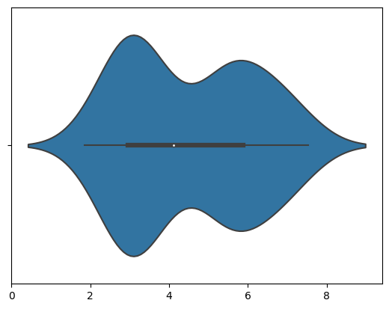



a. 2

b. 3

*c. 4

d. 7.5

**The white dot